LIGHTING CONTROLS

Generally, lighting management will be carried out by presence and brightness detectors. The type, the number, the brightness, and time delay adjustment values ​​will be adapted to the premises and to the controlled lighting sources. Circuits will be properly subdivided so that only dark areas are lit during the day. All detectors must be adjustable by remote control.

Principles of operation and material requirements

1- Small Premises Management:
Automatic operation by presence and luminosity detector

Detector type PD3N-1C for ceiling mounting (flush-mounted or surface-mounted depending on the nature of the ceiling) of the brand BEG LUXOMAT or technically equivalent and will have the following characteristics:

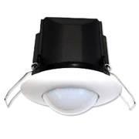
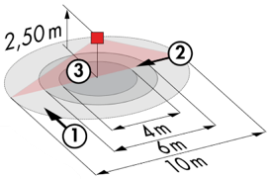
Protection class: SM: IP44, FC: IP23/Class II/CE
Detection area h=2.50 m: Ø 10 m across, Ø 6 m towards, Ø 4 m activity seat
Switching power: 2300W cos φ 1/1150VA cos φ 0.5, LED 300W max
Follow-up time: 30 s to 30 min or pulse / Brightness: 10 to 2000 Lux
Applications: Sanitary / Cloakrooms / Technical rooms / Airlocks...

2- Building Technical Management:
The building will be equipped with a GTB allowing the control of different technical batches either by local, automatic, or centralized controls. The system will ensure the modularity of the installations, making it possible to easily modify the partitions, without having to intervene in the lighting or wiring, and will have to be scalable, making it possible to anticipate a possible extension to new installations. The principle will be based on a KNX BUS. Commissioning and modifications will be carried out via the dedicated “ETS” programming software, connected locally via a KNX/IP interface or via a WEB interface on the LAN or WLAN network and will be carried out by a KNX certified integrator. The system will allow, via a supervision, a complete control of the installations, a visualization of status and the reception of information for maintenance.

Through the components connected to the BUS, this solution will provide the following characteristics:

2.1- Lighting Management
A lighting management system will be installed in each room, allowing the light sources to be completely switched off when unoccupied or when there is sufficient natural light in the room. The system will be composed of presence sensors, digital switching or DALI dimming actuators depending on the nature of the luminaires, associated with local KNX push-button controls.

Management of corridors, staircases, and exteriors
- Automatic switching on by the GTC at the minimum regulatory threshold. By presence detection and according to the natural light, switching on at the set value.
- Forcing of status possible by the GTB

In the room corridors, the operation will be as follows:

- Daytime operation: By time circuit, during the hours of public occupation in the building, in case of unoccupation, the lighting of the corridors will be switched on at the minimum regulatory value. By presence detection, switching on at the set value
- Night operation: By time circuit, outside the hours of public occupation in the building, the lighting of the corridors will be lowered to the minimum regulatory value, thus avoiding too much light entering the residents' rooms during the nurses' rounds

Operating principles of the Rooms:
- Bathroom management
Automatic operation by presence and luminosity detector
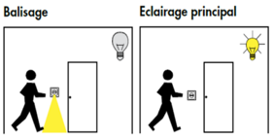
- Orientation lighting management
Automatic operation by presence and luminosity detector. The beaconing will allow the nurse carrying out his rounds or the resident to bring an orientation light in case of detection
- Entrance lighting management
Semi-automatic operation by absence and luminosity detector. A push button, integrated in the detector, will allow the entrance lighting to be switched on manually and voluntarily. Only the extinction will be automatic

Exhibition management:
- Semi-automatic operation by absence detector on DALI dimmable luminaires with Tunable White equipped with "DT8" type drivers. The lighting management system will ensure a change in colour temperature of the luminaires to reproduce the natural cycle of the sun, "Circadian" biodynamic lighting. The lighting near the windows will be controlled independently of the lighting on the corridor side, allowing for natural light. The lighting will be switched on manually and voluntarily by pressing a button. Only the variation, considering the natural light, the change of color temperature and the extinction will be automatic. The system will also allow users to temporarily control the switching on and off and dimming, but not to change the color temperature.
- Creation of scenarios according to the activity carried out

2.2- Air change management
The air renewal of each room will be controlled automatically, considering the occupation of the room and the quality of the ambient air. Information on room occupancy will be sent to the HVAC package via presence sensors and information on air quality via a VOC sensor (Volatile Organic Compounds).

2.3- Temperature management
Each room will be equipped with a temperature sensor and a presence sensor, associated with a weather station and an annual time circuit according to the occupation of the building. The temperature of each room can be adapted to the information retrieved on the KNX bus (temperature increase in advance in case of extreme cold, reduced temperature at night…). By customer request, it will be possible, in each room, to increase or decrease the temperature set point by +/-2°C by means of the thermostat located locally.

2.4- Shutter and sunshade management
The control of the sunshades and roller shutters will be carried out automatically by the BMS or locally by “KNX” type pushbuttons located in each permanently occupied room (offices, meeting rooms…). The common areas will be controlled solely by the BMS. A KNX weather station will be connected to the system to control the brises soleil according to the weather outside.

The KNX system selected will be of the brand BEG LUXOMAT or technically equivalent, comprising the following equipment

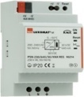
- KNX power supply type PSN-230/640/30-KNX-REG
230V AC / 30V DC BUS KNX / 640mA/ 1000m BUS max
Integrated choke to supply the bus with constant and stabilized current
Up to 64 participants on the KNX BUS (Multi-sensors / PB interfaces / Actuators…)

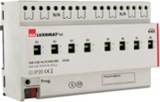
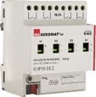
- Switching actuator “TOR” type SA4/8/230/16/H/KNX REG
Power supply via KNX BUS
Outputs: 4 (SA4) or 8 (SA8) 16 A switching outputs
Current measurement possible with actuator type SA4/8-230/16/H/EM/KNX REG
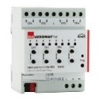
- KNX blind actuator type SBA4-230/10/H/KNX REG
Power supply via KNX BUS
Control of 4 AC motors 230 V max. 600 W
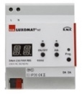
- DALI/KNX Gateway type DA64-230/KNX REG
Power supply 230V AC – Communication via KNX BUS
DALI BUS supply for 64 luminaires in 16 groups / 16 scenes
Support for RGB and TW (Tunable White – DALI Type 8)

- KNX multi-sensor type PDx-KNX-BA/ST/DX
Power supply and communication via KNX BUS

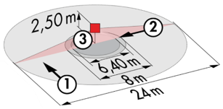
PD4-KNX-C SM/FC/FM (DX): 40 x 5 m angled, 20 x 3 towards, Ø 8 m vertical
Applications: Circulation
PD4-KNX SM/FC/FM (BA-ST-DX): Ø 24 m across, Ø 8 m towards, Ø 6,40 m seated
Applications: Halls / Waiting areas / Lounges, HCL Management
RC-plus 230 KNX (DX): 20 m across, 6 m towards, 4 m vertical
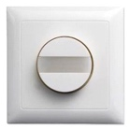
Applications: Stairs / Outdoor
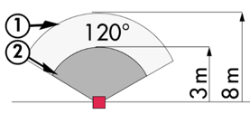
PD11-KNX-FC (BA/ST/BX): Ø 9 m across, Ø 6 m towards, Ø 3 m seated
Applications: Shower
INDOOR-140-L-KNX (DX): 8 m across, 3 m towards
Applications: Rooms / Orientation light

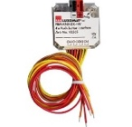
- KNX PB interface type BP-KNX-DX-4W
Power supply and communication via KNX BUS
Up to 4 pushbuttons as imput
Can be combined with all manufacturers’ pushbuttons
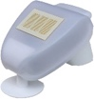
- KNX Weather Station type KNX-WTS-GPS
Power supply and communication via KNX BUS
Wind, Rain, Dusk, Temperature and Light Sensors

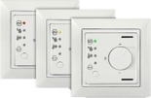
- VOC sensor type WS-VOC-HVAC-KNX
Power supply and communication via KNX BUS
Temperature sensors, room thermostat, VOC sensor (Volatile Organic Compounds)
Humidity Sensor and CO₂ Sensor

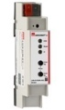
- KNX Router and IP interface
Power supply and communication via KNX BUS
Router LK-IP/KNX-REG: Enables the transfer of telegrams between different KNX segments via a LAN (IP)
LAN-IF/KNX-REG IP interface: Connection of a PC for addressing via LAN bus, programming, and diagnostics of KNX components

