LIGHTING CONTROL

Generally, the lighting will be controlled by presence and luminosity detectors or automatic luminaires. The nature of the detectors or automatic luminaires, the number, the brightness, and time settings shall be adapted to the premises and the lighting sources being controlled. Circuits shall be properly subdivided so that only dark areas are lit during the day. All detectors shall be adjustable by remote control.

Operating principles and material requirements

1- Management of the entrance hall, common corridors, stairwells, airlocks, small rooms, outside areas and car park:
Automatic operation by presence and luminosity detector

Detector type PD4N-1C-C-FC for ceiling mounting (recessed or surface mounting depending on the nature of the ceiling) associated with LED lights of the brand BEG LUXOMAT or technically equivalent and will have the following characteristics:
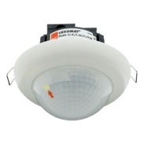
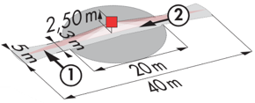
Protection class: SM: IP44, FC: IP23/Class II/CE
Detection area h=2.50 m: 40 x 5 m across, 20 x 3 m towards, Ø8 m vertical
Switching power: 2300W cos φ 1/1150VA cos φ 0.5, LED 300W max
Follow-up time: 30 s to 30 min or pulse / Brightness: 10 to 2000 Lux

Surface mounted LED window "Round" type AL8-25-300-LED-3C or "Square" type AL12-25-300-LED-3C in ceiling mounting of the brand BEG LUXOMAT or technically equivalent and will have the following characteristics:
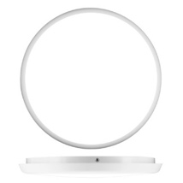
Protection class: IK10 / IP54/Class II/CE
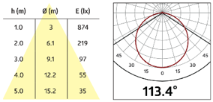
LED power: 25w, Lifetime: > 50 000 H / L80 B10
3 integrated colors temperatures: 3000K / 4000K / 5700K
Luminous flux: 2000lms (3000K) / 2500lms (4000K) / 2400lms (5700K)
Luminous efficacy: 80 / 100 / 96 lm/w
CRI: 80, Photobiological risks: RG0
Glare: UGR< 25
Applications: Circulation

Detector type PD4N-1C-SM for surface mounting on the ceiling of the brand BEG LUXOMAT or technically equivalent and will have the following characteristics:
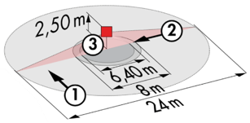
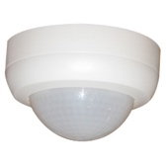
Protection class: SM: IP44
Detection area h=2.50 m: Ø 24 m across, Ø8 m towards, Ø6,40 m seat activity
Switching power: 2300W cos φ 1/1150VA cos φ 0.5, LED 3000W max
Follow-up time: 30 s to 30 min or pulse / Brightness: 10 to 2000 Lux
Applications: Parking

Detector type PD3N-1C for ceiling mounting (flush-mounted or surface-mounted depending on the nature of the ceiling) of the brand BEG LUXOMAT or technically equivalent and will have the following characteristics:
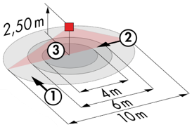
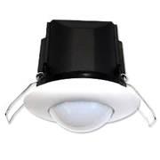
Protection class: SM: IP44, FC: IP23/Class II/CE
Detection area h=2.50 m: Ø 10 m across, Ø 6 m towards, Ø 4 m activity seat
Switching power: 2300W cos φ 1/1150VA cos φ 0.5, LED 300W max
Follow-up time: 30 s to 30 min or pulse / Brightness: 10 to 2000 Lux

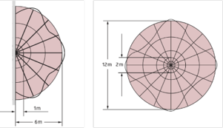
Surface mounted LED window " Round " type AL8-25-300-LED-3C-Microwave or " Square " type AL12-25-300-LED-3C-HF for wall or ceiling mounting of the brand BEG LUXOMAT or technically equivalent and will have the following characteristics

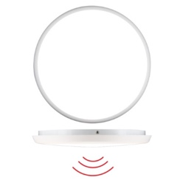
Protection class: IK10 / IP20/Class II/CE
LED power: 25w, Lifetime: > 50 000 H / L80 B10
3 integrated colors temperatures: 3000K / 4000K / 5700K
Luminous flux: 2000lms (3000K) / 2500lms (4000K) / 2400lms (5700K)
Luminous efficacy: 80 / 100 / 96 lm/w
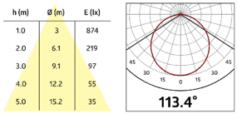
CRI: 80, Photobiological risks: RG0
Glare: UGR< 25
5.8 GHz microwave sensor
Detection zone for wall mounting h=1.50m: Towardsal range from 1 to 6 m
Detection zone for ceiling mounting h= 2.50m: Towardsal range adjustable from Ø 2 to Ø 12 m
Follow-up time: 20 s to 10 min or pulse / Brightness: 5 to 50 Lux or Off
Applications: Entrance Hall / Stairwells / Airlock / Small rooms...

LC Plus 280° wall-mounted detector of the brand BEG LUXOMAT or technically equivalent and will have the following characteristics:

Degree / protection class: IP54/Class II/CE
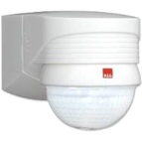
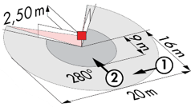
Detection area: h=2,50 m: 16 m across, 9 m towards, 2 m vertical
Switching power: 2000W cos φ 1/1000VA cos φ 0.5, LED 250W maxi
Follow-up time: 15 s to 16 min or pulse / Brightness: 2 to 2500 Lux
Applications: Outdoor / Parking for wall mounting

Surface mounted LED window "Round" type AL93-20-300-LED-3C-Microwave for ceiling mounting of the brand BEG LUXOMAT or technically equivalent and will have the following characteristics:

Protection class: IK08 / IP54/Class II/CE
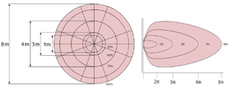
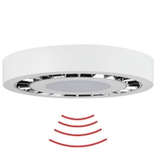
Power: 20w, Lifetime: > 50 000 H L80 B10
3 integrated colors temperatures: 3000K / 4000K / 5700K
Luminous Flux: 1600lms (3000K) / 1850lms (4000K) / 1700lms (5700K)
Luminous efficacy: 80 / 92 / 85 lm/w
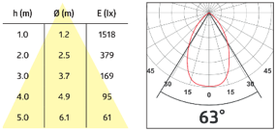
CRI: 80, Photobiological risks: RG0
Glare: UGR< 19
5.8 GHz microwave sensor
Detection zone for wall mounting h=1.50m: Towardsal range from 2 to 7 m
Detection zone for ceiling mounting h= 2.50m: Towardsal range adjustable from Ø 1 to Ø 8 m
Follow-up time: 5 s to 30 min or pulse / Brightness: 5 to 50 Lux or Off
Applications: Airlock / Household / Dustbin room / Cellar...

