LIGHTING CONTROLS

Generally, lighting management will be carried out by presence and brightness detectors. The type, the number, the brightness, and time delay adjustment values ​​will be adapted to the premises and to the controlled lighting sources. Circuits will be properly subdivided so that only dark areas are lit during the day. All detectors must be adjustable by remote control.

Principles of operation and material requirements

1- Traffic, Stairwells, Exteriors, Small Premises, Parking Management:
Automatic operation by presence and light detector

Typical detector PD4-M-1C-Corridor + Slaves in ceiling mounting (recessed or surface-mounted depending on the nature of the ceiling) of the BEG LUXOMAT brand or technically equivalent and will have the following characteristics:
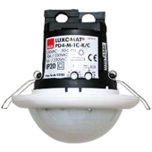
Degree / protection class: SM: IP54 with base, FC: IP20/Class II/CE
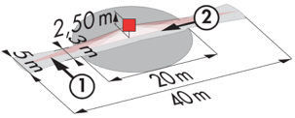
Detection area: h=2,50 m: 40 x 5 m across, 20 x 3 m towards, Ø8 m vertical
Switching power: 2300W cos φ 1/1150VA cos φ 0.5, LED 300W maxi
Follow-up time: 30 s to 30 min or pulse / Brightness: 10 to 2000 Lux
Permanent control of daylight and artificial light
Applications: Circulations

LC Plus 280° wall-mounted detector of the brand BEG LUXOMAT or technically equivalent and will have the following characteristics:
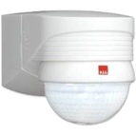
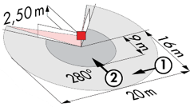
Degree / protection class: IP54/Class II/CE
Detection area: h=2,50 m: 16 m across, 9 m towards, 2 m vertical
Switching power: 2000W cos φ 1/1000VA cos φ 0.5, LED 250W maxi
Follow-up time: 15 s to 16 min or pulse / Brightness: 2 to 2500 Lux
Applications: Stair / Outdoor

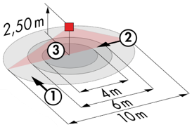
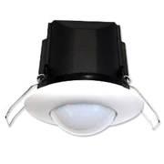
Typical detector PD3N-1C for ceiling mounting (recessed or surface-mounted depending on the nature of the ceiling) of the BEG LUXOMAT brand or technically equivalent and will have the following characteristics:

Degree / protection class: IP44, FC: IP54/Class II/CE
Detection area: h=2,50 m: Ø 10 m across, 6 m towards, 4 m seated
Switching power: 2300W cos φ 1/1150VA cos φ 0.5, LED 300W maxi
Follow-up time: 30 s to 30 min or pulse / Brightness: 10 to 2500 Lux
Applications: Toilets / Lockers rooms / Equipment rooms / Airlocks…

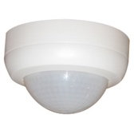
Typical detector PD4N-1C-SM for surface mounting on the ceiling of the BEG LUXOMAT brand or technically equivalent and will have the following characteristics:
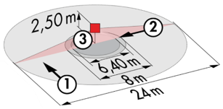
Degree / protection class: SM: IP44
Detection area: h=2,50 m: Ø 24 m across, 8 m towards, 6,40 m seated
Switching power: 2300W cos φ 1/1150VA cos φ 0.5, LED 300W maxi
Follow-up time: 30 s to 30 min or pulse / Brightness: 10 to 2000 Lux
Applications: Parking

2- Management Office:
Semi-automatic operation by absence detector on DALI dimmable luminaires. The lighting will be switched on manually and voluntary by pressing the push-button. Only dimming, considering natural light, and switching off will be automatic. The control panel will also allow the user to manually control the lighting, allowing the user to temporally force the status of luminaires to be switched on, off and dimmed.

3- Shelf Management Office
Automatic operation by presence detector on DALI dimmable luminaires. One detector per 13m² grid on 2 luminaires maximum, allowing modularity of partitions by rewiring. When modifying the partitions, at the customer's request, a local override command can be added, physically by installing a push button or by supplying a mini user remote control. This local override command will allow the user to take manual control of the lighting, thus temporarily forcing the lighting to be switched on, off or dimmed.

Detector type: PDN-M-DACO-1C DALI-2 in ceiling mounting (recessed or surface-mounted depending on the nature of the ceiling) of the BEG LUXOMAT brand or technically equivalent and will have the following characteristics:

Degree / protection class: SM: IP54 with surface mount accessory, FC: IP20/Class II/CE
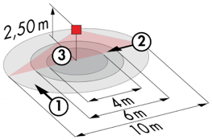
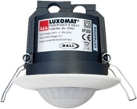
Detection area: h=2,50 m: Ø 10 m across, Ø 6 m towards, Ø 4 m seated
Interface: DALI-2 certified, digital driver control in broadcast mode
Built-in relay: driver shutdown in standby mode, HVAC, Slave Function
Switching power: 2300W cos φ 1/1150VA cos φ 0.5, LED 300W maxi
Follow-up time: 1 min to 150 min or pulse / Brightness: 10 to 5200 Lux
Daylight-dependent constant dimming / DALI digital drivers 40
Settings: via bi-directional BEG One Smartphone application (read/write)
Applications: Offices / Office Trailers

4- Meeting Room Management:
Semi-automatic operation by absence detector on DALI dimmable luminaires. The lighting located near the windows will be controlled independently of the lighting on the corridor side to take account of natural light. The lighting will be switched on manually and voluntary by pressing the push-button. Only the variation, considering the natural light, and the extinction will be automatic. The PB will also allow the user to manually control the lighting, allowing him to temporarily force the state of the luminaires to be switched on, off and dimmed. The system will also offer the possibility of creating lighting scenarios, for example for video conferencing or projection. Commissioning and modifications will be carried out via a dedicated Smartphone application in BLE (Bluetooth) communication with the system. It will be the responsibility of the holder of the present lot or by a manufacturer’s commissioning service.

The principle chosen will be the DALI-LINK brand BEG LUXOMAT or technically equivalent, comprising the following equipment:

- DALI BUS power supply type PS-DALI-LINK-100mA with the following characteristics:
Main’s supply 230V AC / DALI BUS supply 16V DC / 100 mA / 300m BUS max
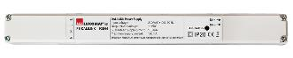
Auto-addressing of components on the BUS
Control of up to 25 DALI luminaires and 6 control devices
(Multi sensors/ PB interfaces…)
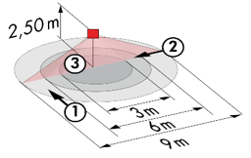
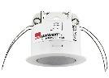
8 control zones maximum per power supply / 16 groups / 16 scenes

- Multi DALI sensors with the following characteristics:
Power supply and communication via DALI BUS 16V DC
Protection class: IP20/Class 2
Functions: Master / Slave / Switching or Control / Lighting sensor
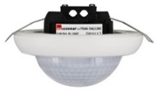
Type PD11-DALI-LINK
Detection area h=2,50 m: Ø 9 m across, 6 m towards, 3 m seated
Type PD4N-DALI-LINK
Detection area h=2,50 m: Ø 24 m across, 8 m towards, 6,40 m seated

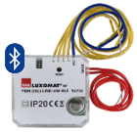
- DALI PB interface type PBM-DALI-LINK-4W-BLE with the following characteristics:
Power supply and communication via DALI BUS 16V DC
Bluetooth communication for setting up
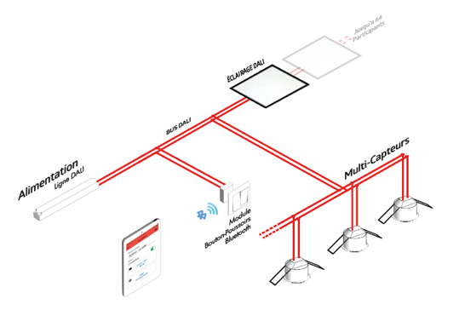
4 independently interfaceable binary inputs
Can be combined with all manufacturers’ pushbuttons
Variant without Bluetooth: PBM-DALI-LINK-4W
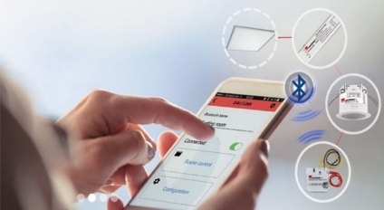

4- Management of loading areas, storage aisles and access to racks
Automatic operation by high-level presence detector on DALI dimmable luminaires. Switching on at the set value when present in the rack, automatic dimming according to natural light. In the event of unoccupied loading areas, racks and rack access corridors, minimum dimming for a predefined time or permanently during working hours. The detectors must be positioned carefully so as not to detect people and machinery moving around the racks. The detectors must cover the entire surface of a storage aisle to have detection at all points. Outside of staff occupancy hours, the lighting will be switched off completely.

Detector type PD4-M-DACO-DALI2-SM in ceiling surface mounting (on cable tray) of the brand BEG LUXOMAT or technically equivalent and will have the following characteristics

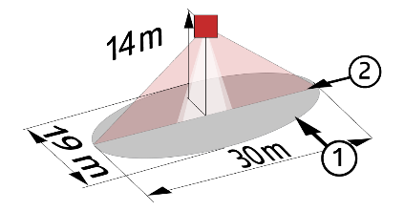
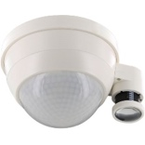
Protection class: SM: IP54/Class II/CE
Detection area h=10 m: Ø 30 x Ø 19 m towards
Interface: DALI 2 certified, digital driver control in broadcast mode
Follow-up time: 1 to 150 min or pulse / Brightness: 10 to 2500 Lux
Beaconing function at 10 to 30% in case of unoccupancy / 40 digital DALI drivers
Settings: Via bi-directional BEG-One smartphone application (read/write)
Applications: Loading areas / Storage aisles / Rack access aisles

